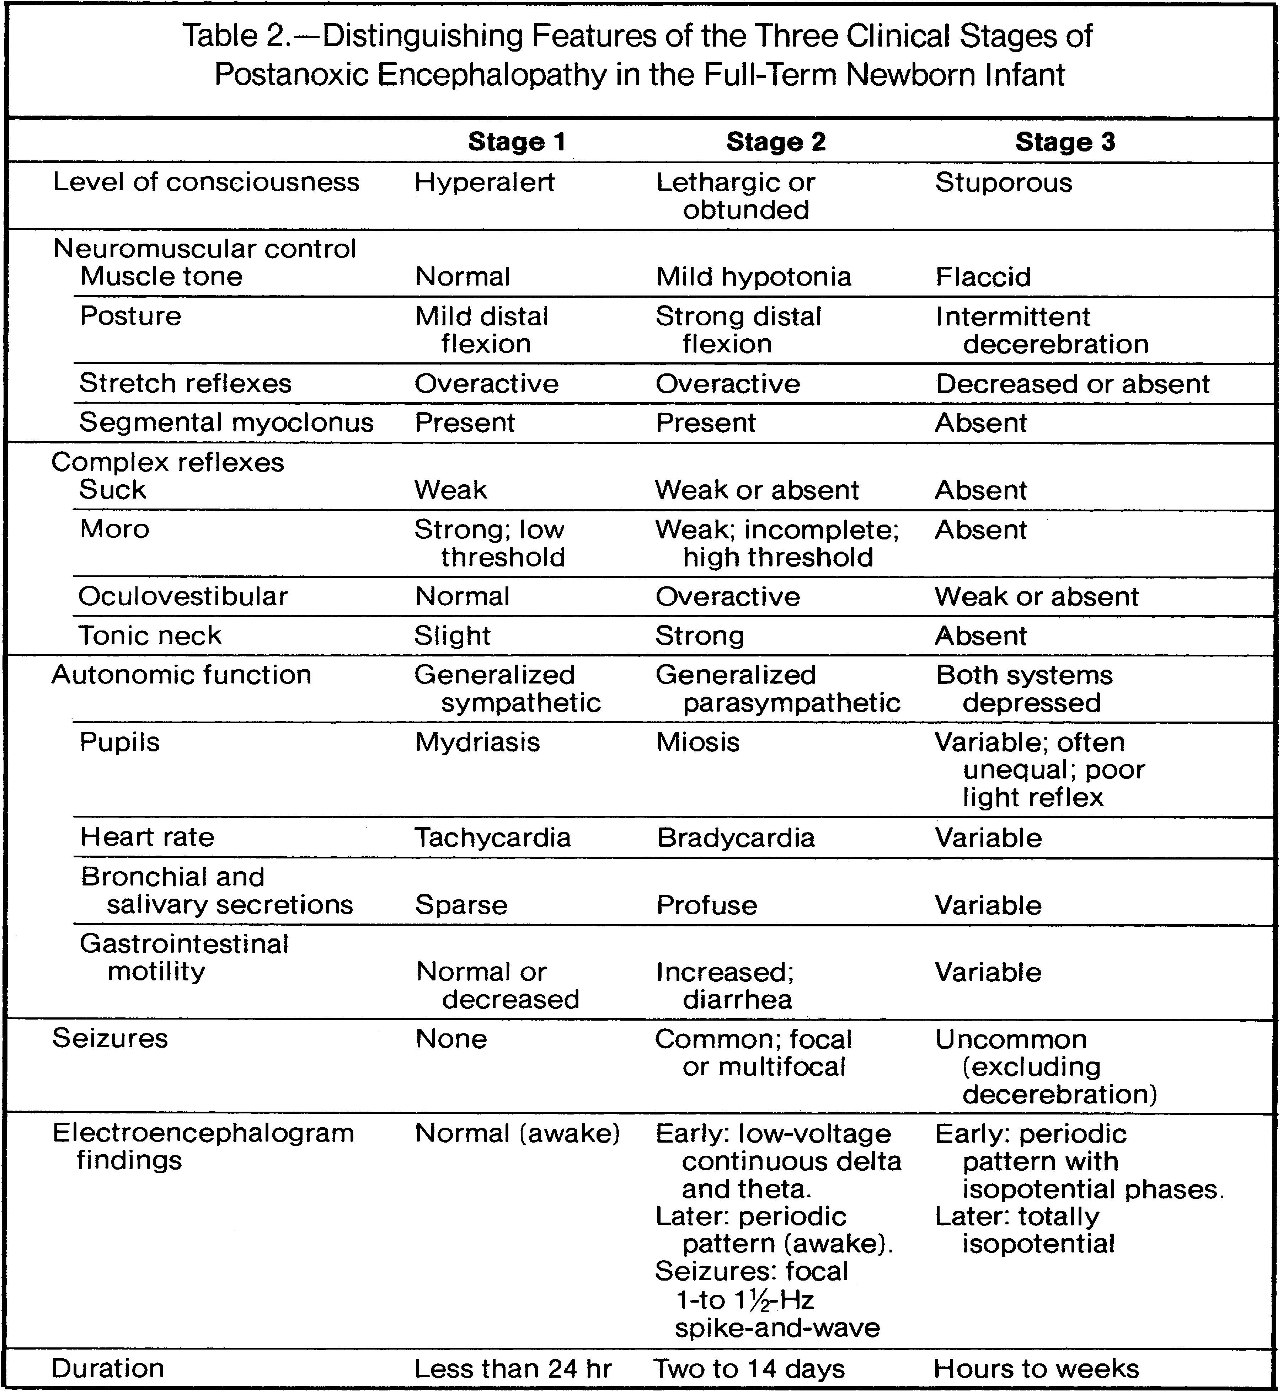

Table 1: The original Sarnat and Sarnat staging system, which was published in their seminal paper in Archives of Neurology in 1976
Therapeutic Target | Study  (Clinical Trials.gov ID) | Participants | Experimental Protocol | Primary Outcomes | Secondary Outcomes | Status
Xenon | CoolXenon3  [NCT02071394]  UK | Infants with HIE  > 36 weeks | cooling +  18h xenon inhalation at 50% concentration | Death and moderate to severe disability at 18 months | Brain MRI (within 2 weeks of birth)  aEEG grading within 1 week of birth)  Developmental Outcomes at 18-24 months | Phase 2: Recruiting
Topiramate | [NCT01765218]  USA | Infants with HIE >=34 weeks | Cooling +  Topiramate (5 mg/kg/day) for total of 5 doses | Seizures at 4 weeks or at discharge | HIE score at 4 weeks or at discharge  Normalization of aEEG at 4 weeks or at discharge  S100-beta levels at 1, 3 ,7 days  MRI score at 5-7 days  Developmental Outcomes at 9,18,27 months | Phase 1,2: Completed
Allopurinol | ALBINO  [NCT03162653]  Europe | Infants with HIE >=36 weeks | Cooling +  Allopurinol (20mg/kg) within 30 minutes of birth and (10mg/kg) 12 h thereafter | Death and moderate to severe disability at 24 months | Incidence of Death and CP at 24 months  GMFCS-score at 24 months  Developmental outcomes at 24 months | Phase 3:  Not yet recruiting
Melatonin | [NCT02621944]  USA | Infants with HIE >=36 weeks | Cooling +  melatonin (0.5mg/kg within 12 h after birth | MTD  Pharmacokinetics of escalated doses  Adverse events  Developmental outcomes at 18-20 months | Developmental outcomes subscales at 18-20 months  GMA at 3 and 23 months  Brain MRI 7-12 days after birth | Phase 1: Recruiting
Erythropoietin | PAEAN  [NCT03079167]  Australia and New Zealand | Infants with HIE >=35 weeks | Cooling + erythropoietin  (1000 IU/kg BW), on days 1,2,3,5,7 of age | Death and moderate/severe disability at 24 months | Death and CP at 24 months  Developmental outcomes at 24 months  Epilepsy at 24 months  Cost of healthcare  Frequency of AED | Phase 3:  Recruiting
 | NEATO  [NCT01913340]  USA | Infants with HIE >=36 weeks | Cooling + erythropoietin  (1000 IU/kg BW) total of 5 doses | Markers of organ function for 2 weeks | Developmental and functional outcomes at 12 months | Phase 1, 2: Not yet recruiting
 | Neurepo  [NCT01732146 ]  France | Infants with HIE >=36 weeks | Cooling + erythropoietin  (1000-1500 IU/kg BW) total of 3 doses | Survival without neurological sequelae  At 2 years | Death and Moderate/severe disability at 24 months  Brain MRI within 6-12 days  Tolerance at 2 years | Phase 3: Recruiting
 | PENUT  [NCT01378273]  USA | Preterm infants 24-27 weeks of gestation | Cooling +  erythropoietin (1000 IU/kg BW) for total of 6 doses followed by 400 U/kg until 32 6/7 weeks of gestation | Neurodevelopmental outcomes at 24-26 months | Safety at term PMA  Brain MRI at 36 weeks PMA  Inflammation biomarkers at 24-26 months | Phase 3: Not yet recruiting
Cell-Based | [NCT02455830]  Japan | Infants with HIE >=36 weeks | Cooling +  Autologous cord blood cell infusion (3 doses within 72 h) | Changes in cytokines and trophic factors level for 10 days | Brain MRI at 12 months  Developmental and functional outcomes at 18 months  Correlation with cytokines profile | Phase 1: Recruiting
 | [NCT02256618]  Japan | Infants with HIE >=36 weeks | Cooling +  Autologous umbilical cord blood cells (3 doses within 72 h) | Adverse events at 30 days | Neurodevelopmental function at 18 months  Brain MRI at 12 months | Phase 1: Recruiting
 | [NCT02551003]  China | Infants with HIE >=34 weeks | Cooling +  Autologous umbilical cord blood cells (divided doses within 72 h) | Death and neurodevelopmental disability within 18 months | Neurodevelopmental outcomes at 12 and 18 months  Brain MRI at 7, 28 days and 12 months  Adverse events within 72 h  Serum SDF-1, TNF-alpha, IL-1 at 4 and 14 days | Phase 1,2: Recruiting
 | [NCT02612155]  USA | Infants with HIE >=35 weeks | Cooling +  Autologous umbilical cord blood cells (2 doses) | Survival at 1 year  Neurodevelopmental outcomes at 1 year | Mortality rate , seizures and AED, Need for iNO use, ECMO and G tube feeding at 12 months | Phase 2: Recruiting
 | [NCT02854579]  China | Infants with HIE >=34 weeks | Neural progenitor cells and/or paracrine factors intrathecal infusion | Neurodevelopmental outcomes at 14 and 28 days  Adverse events at 7 days | Neurodevelopmental outcomes at 1 2 months  Death within 12 months  Treatment-related CNS tumor within 5 years | Phase 1:  Recruiting

Table (2): Description of active clinical trials pursuing new neuroprotective strategies for neonates with Hypoxic Ischemic Injury. h: hour; MRI: Magnetic Resonance Imaging; aEEG: amplitude integrated EEG. S100-Beta: marker of neuronal injury; CP: cerebral palsy; MTD: maximum tolerated dose; GMA: generalized motor assessment; AED: anti-epileptic drugs; PMA: Post menstrual age; SDF-1, TNF-alpha and IL-1: Biomarkers for oxidative stress, Inflammation and immune response.

